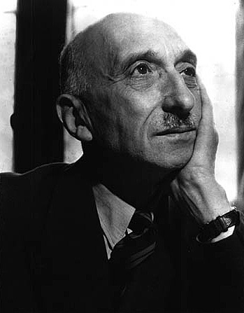

François Mauriac (1885-1970) was a French novelist, essayist, poet, playwright and journalist. He was born in Bordeaux, France. He is best known for depicting trenchant psychological dramas, and Christian characters struggling with a modern world. His widowed mother raised him with a stern, Catholic austerity that profoundly marked his literary works. His stories are typically set in his native Bordeaux and the Landes department in the Southwest of France.
In 1933, Mauriac was elected to the Académie Française. After receiving the 1952 Nobel Prize for Literature, he became a prominent polemical journalist and he virulently denounced fascism. In 1958, he was awarded the Grand Cross of the Légion d’honneur. He became an official supporter of Charles De Gaulle in 1962.

References and Further Reading:

Keating, L. C. (ed.) (1953) ‘Introduction: François Mauriac’, Les Chemins de la Mer. Boston: D. C. Heath and Company.

The Nobel Prize in Literature 1952. (2012, July 1) Nobelprize.org. Retrieved from http://www.nobelprize.org/nobel_prizes/literature/laureates/1952/

List of Major Works:

1913 – L’Enfant chargé de chaînes (Young Man in Chains, tr. 1961)
1922 – Le Baiser au lépreux (The Kiss to the Leper, tr. 1923 / A Kiss to the Leper , tr.1950)
1925 – Le Désert de l’amour (The Desert of Love, tr. 1949)
1927 – Thérèse Desqueyroux (Thérèse, tr. 1928 / Thérèse Desqueyroux, tr. 1947 and 2005)
1932 – Le Nœud de Vipères (Viper’s Tangle, tr. 1933 / The Knot of Vipers, tr. 1951)

Photographic source:

http://www.google.com/imgres?hl=en&sa=G&biw=1173&bih=620&tbm=isch&tbnid=oEvfK88CFnenFM:&imgrefurl=http://www.bookine.net/mauriac.htm&docid=wyto0JUquM-HHM&imgurl=http://www.bookine.net/mauriac02.jpg&w=349&h=447&ei=CAT3T9vyGPGK2QW85sn-Bg&zoom=1&iact=hc&vpx=211&vpy=118&dur=1368&hovh=254&hovw=198&tx=124&ty=125&sig=111884008505274887091&page=1&tbnh=132&tbnw=103&start=0&ndsp=24&ved=1t:429,r:1,s:0,i:79

